**Title: Enhancing Efficiency and Transparency: A Real Estate Management System Abstract**

The real estate industry is undergoing a significant transformation with the advent of advanced technology. In this abstract, we present a comprehensive overview of a Real Estate Management System (REMS) designed to streamline processes, enhance efficiency, and promote transparency in the management of real estate assets.

REMS is a digital platform equipped with robust features to cater to the diverse needs of property owners, tenants, and real estate professionals. It offers functionalities such as property listing and search, lease management, financial tracking, maintenance scheduling, and reporting capabilities.

In conclusion, REMS represents a paradigm shift in real estate management, offering a holistic solution to streamline operations, enhance efficiency, and promote transparency. By leveraging advanced technology and innovative features, REMS empowers stakeholders to maximize the value of their real estate assets in an increasingly competitive market landscape.

**Introduction to Real Estate Management System**

In today's dynamic and ever-evolving real estate market, efficient management and streamlined operations are crucial for property owners, managers, investors, and tenants alike. A Real Estate Management System (REMS) serves as an indispensable tool in this regard, providing a comprehensive platform to manage various aspects of real estate operations seamlessly.

A Real Estate Management System integrates various functionalities into a single, cohesive platform to support the end-to-end management of properties. This includes residential, commercial, and industrial real estate. The primary goal of a REMS is to enhance productivity, improve accuracy, and ensure the smooth execution of tasks related to property management.

The adoption of a Real Estate Management System can lead to significant benefits, including:

* **Increased Efficiency**: Automation of routine tasks reduces manual efforts and errors, freeing up time for strategic activities.
* **Enhanced Visibility**: Real-time access to data and comprehensive dashboards provide better visibility into operations and performance.
* **Improved Tenant Satisfaction**: Streamlined processes and responsive management improve the tenant experience, leading to higher retention rates.
* **Cost Savings**: Optimized maintenance schedules, efficient resource allocation, and better financial management contribute to cost reductions.

In conclusion, a Real Estate Management System is a critical asset for modern real estate operations, offering a robust framework to manage properties efficiently, ensure compliance, and drive profitability. As technology continues to advance, the capabilities of REMS will further evolve, enabling real estate professionals to meet the challenges of the market with agility and precision.

### Functional Requirements for a Real Estate Management System

A Real Estate Management System (REMS) is designed to handle the multifaceted needs of real estate operations, from property listing to maintenance, financial management, and beyond. Here are the detailed functional requirements:

#### 1. Property Management

* **Property Listings and Descriptions**: Ability to create and manage property listings with detailed descriptions, photographs, videos, virtual tours, and amenities.
* **Property Categorization**: Support for categorizing properties (residential, commercial, industrial) and specifying property types (apartments, offices, warehouses).

#### 2. Tenant and Lease Management

* **Tenant Onboarding**: Facilitate the onboarding process for new tenants, including application processing, background checks, and document verification.
* **Lease Agreement Management**: Create, store, and manage lease agreements, including electronic signatures and document templates.
* **Rent Collection**: Automate rent collection, track payment statuses, send reminders, and handle late payments.
* **Tenant Communication**: Provide a communication portal for tenants to submit requests, complaints, and communicate with property managers.

#### 3. Maintenance and Facility Management

* **Maintenance Requests**: Allow tenants and property managers to submit and track maintenance requests.
* **Work Order Management**: Generate, assign, and track work orders for maintenance tasks.
* **Vendor Management**: Manage vendor information, service contracts, and performance tracking.
* **Scheduling**: Schedule routine maintenance and inspections, and track their completion.

#### 4. Financial Management

* **Accounting**: Integrate accounting functionalities to manage income, expenses, and financial transactions.
* **Budgeting**: Create and manage budgets for properties, track expenses against budgets, and generate financial forecasts.
* **Invoicing and Payments**: Generate invoices for rent, utilities, and other services, and manage payment processing.
* **Financial Reporting**: Generate comprehensive financial reports, including profit and loss statements, balance sheets, and cash flow reports.

#### 5. Document Management

* **Document Storage**: Secure storage for all property-related documents, including lease agreements, property deeds, and compliance certificates.
* **Document Retrieval**: Efficient search and retrieval system for accessing stored documents.
* **Version Control**: Maintain version control for documents, tracking changes and updates.

#### 6. Analytics and Reporting

* **Performance Analytics**: Provide analytics on property performance, occupancy rates, rental income, and maintenance costs.
* **Market Analysis**: Tools for analyzing market trends, rental prices, and property values.
* **Custom Reports**: Ability to generate custom reports based on various parameters and metrics.

#### 7. Customer Relationship Management (CRM)

* **Contact Management**: Manage contact information for tenants, buyers, vendors, and other stakeholders.
* **Communication Tools**: Provide tools for email marketing, notifications, and customer service.
* **Feedback Management**: Collect and manage feedback from tenants and other stakeholders.

#### 8. Compliance and Risk Management

* **Regulatory Compliance**: Ensure properties comply with local regulations and standards, including safety and accessibility requirements.
* **Risk Assessment**: Tools for assessing and managing risks associated with property management.
* **Insurance Management**: Track insurance policies, claims, and renewals.

#### 9. User and Access Management

* **Role-Based Access Control**: Define user roles and permissions to ensure secure access to system functionalities and data.
* **User Authentication**: Secure user authentication mechanisms, including multi-factor authentication (MFA).

#### 10. Integration and Compatibility

* **Third-Party Integration**: Ability to integrate with third-party systems such as accounting software, CRM systems, and marketing platforms.
* **API Support**: Provide APIs for seamless integration with other applications and services.
* **Mobile Access**: Support for mobile access to the system, enabling on-the-go management.

Incorporating these functional requirements ensures that a Real Estate Management System is robust, scalable, and capable of meeting the diverse needs of real estate professionals, ultimately leading to more efficient and effective property management.

ER DIAGRAM:

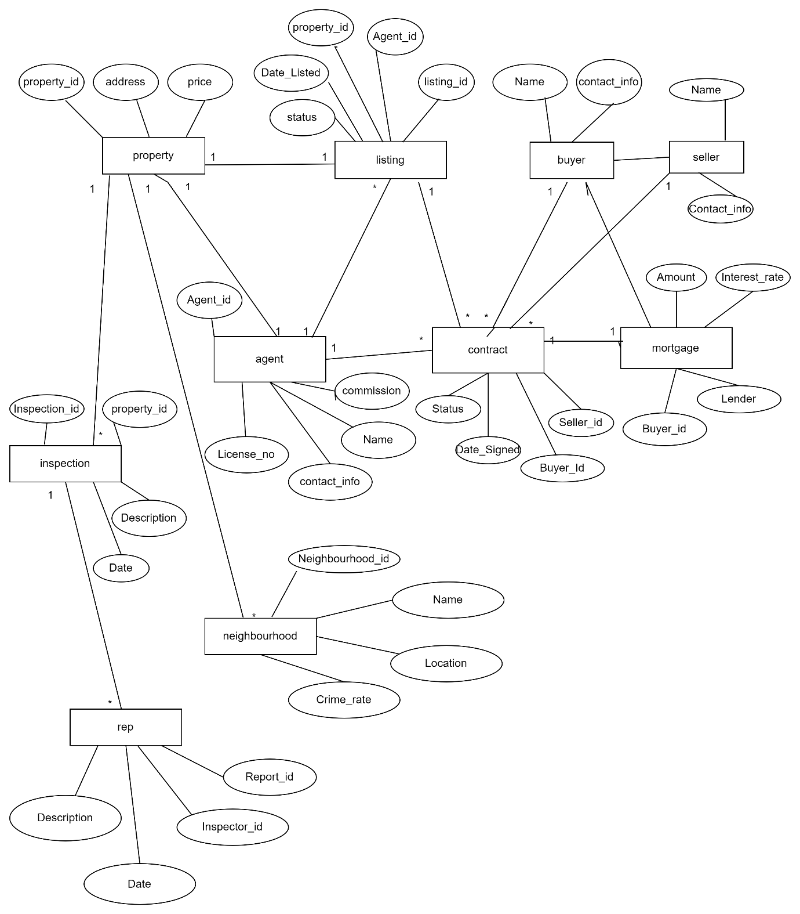

**QUERIES TO CREATE TABLES IN THE DATABASE:**

CREATE TABLE Property (

Property_ID INT PRIMARY KEY,

Address VARCHAR(255),

Type VARCHAR(50),

Bedrooms INT,

Bathrooms INT,

Price DECIMAL(15, 2),

Square_footage INT

);

CREATE TABLE Agent (

Agent_ID INT PRIMARY KEY,

Name VARCHAR(100),

Contact_info VARCHAR(255),

Commission DECIMAL(10, 2),

License_No VARCHAR(50)

);

CREATE TABLE Buyer (

Buyer_ID INT PRIMARY KEY,

Name VARCHAR(100),

Contact_info VARCHAR(255)

);

CREATE TABLE Seller (

Seller_ID INT PRIMARY KEY,

Name VARCHAR(100),

Contact_info VARCHAR(255)

);

CREATE TABLE Listing (

Listing_ID INT PRIMARY KEY,

Agent_ID INT,

Property_ID INT,

Date_Listed DATE,

Status VARCHAR(50),

FOREIGN KEY (Agent_ID) REFERENCES Agent(Agent_ID),

FOREIGN KEY (Property_ID) REFERENCES Property(Property_ID)

);

CREATE TABLE Contract (

Contract_ID INT PRIMARY KEY,

Buyer_ID INT,

Seller_ID INT,

Date_Signed DATE,

Status VARCHAR(50),

FOREIGN KEY (Buyer_ID) REFERENCES Buyer(Buyer_ID),

FOREIGN KEY (Seller_ID) REFERENCES Seller(Seller_ID)

);

CREATE TABLE Mortgage (

Mortgage_ID INT PRIMARY KEY,

Buyer_ID INT,

Lender VARCHAR(100),

Amount DECIMAL(15, 2),

Interest_Rate DECIMAL(5, 2),

Term INT,

FOREIGN KEY (Buyer_ID) REFERENCES Buyer(Buyer_ID)

);

CREATE TABLE Inspection (

Inspection_ID INT PRIMARY KEY,

Property_ID INT,

Date DATE,

Description TEXT,

FOREIGN KEY (Property_ID) REFERENCES Property(Property_ID)

);

CREATE TABLE Neighborhood (

Neighbourhood_ID INT PRIMARY KEY,

Name VARCHAR(100),

Location VARCHAR(255),

Crime_rate DECIMAL(5, 2)

);

CREATE TABLE Report (

Report_ID INT PRIMARY KEY,

Inspector_ID INT,

Date DATE,

Description TEXT,

FOREIGN KEY (Inspector_ID) REFERENCES Agent(Agent_ID)

);

**REAL ESTATE MANAGEMENT SYSTEM**

